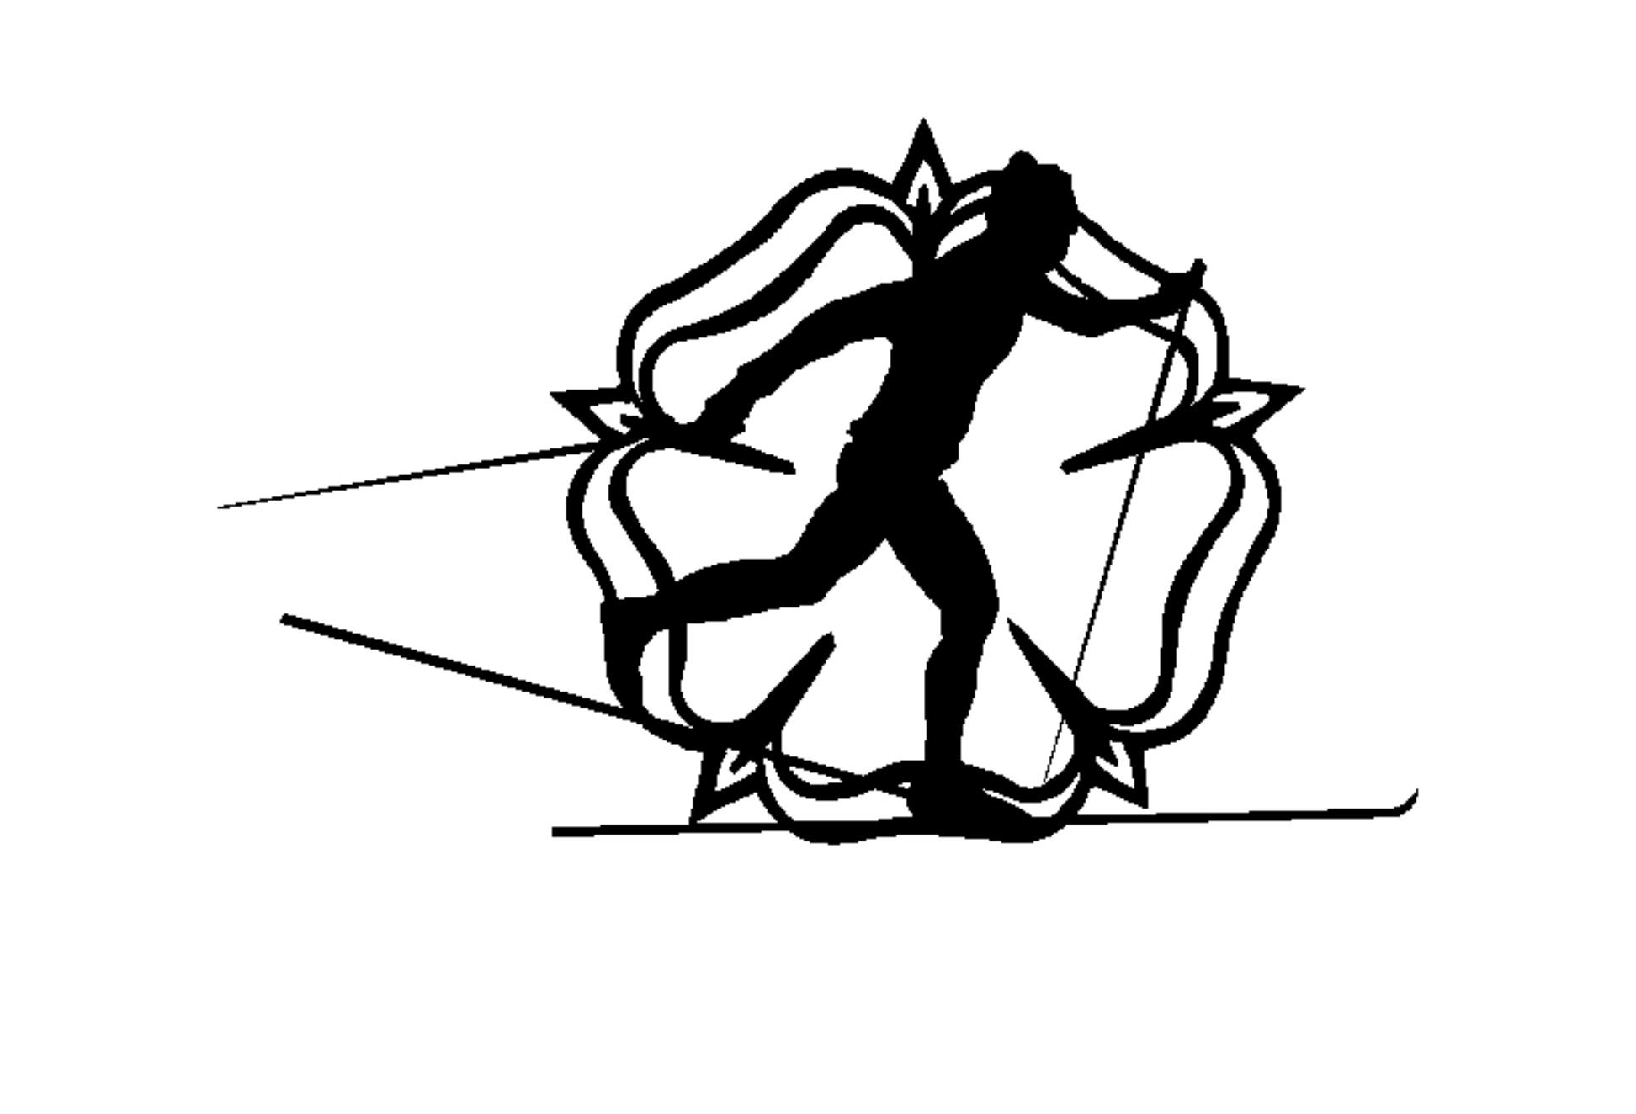
.

Yorkshire Dales Cross Country Ski Club

Roller Ski Information Sheet
August 26

What is roller skiing?
Roller skiing developed as a summer training activity for cross-country skiers. There are the same two styles as on snow, classic and skate: skis and poles are used, just with wheels and without the snow. No previous experience is required, though you will need a reasonable level of fitness and balance to get the most out of it – but this can build up over time. Roller skiing is also a fantastic complement to other sports.

Who roller skis in Yorkshire?
YDCCSC welcomes roller skiers of all abilities. You may have an on-snow holiday booked and want to learn some skills beforehand; you may have cross-country skied previously and want to develop your technique; you may follow cross-country skiing on TV or social media; or you may have never encountered it before and are just looking for an excellent way to achieve a full body workout.

How do I get started?
We offer an initial taster session to anyone new to the Club - the cost is £10 adults/£5 juniors and students, and includes instruction and kit (venue track fee payable in addition). This is usually in classic style, but a skate taster is also possible. Generally our minimum age is 10 due to the focus and balance needed for roller skiing - although we are prepared to arrange a taster for younger children who have cross-country ski experience, or who are confident ice or roller skaters (please ask if this applies).

Following the taster, beginners would take part in a block of introductory sessions. Our Nordic ski instructors will introduce you to roller skiing and build your confidence, agility and skills on the skis. Club instruction is based on the Snowsport England (SE) Nordic Proficiency Awards; and after 3-4 weeks you should have learned all the basic techniques to achieve the 1* award. If you have previous experience and are assessed as already at 1* level in classic and/or skate at your taster session, you would join the Club and be able to take part in our club coaching programme.

Annual YDCCSC membership is £12.50 for adults and £6.25 for juniors and students - Associate Membership is also available for members of other SE-affiliated Nordic Clubs. All roller skiers are also required to become individual members of Snowsport England. Please see our ‘General Information Sheet’ for further details.

What happens after 1*?
Anyone who has reached 1* level can roller ski unsupervised at our circuit sessions and join in with other roller ski events. Members are encouraged to register onto SE’s Proficiency Awards Scheme for a one-off £5 fee, and improve their technique on the Club’s coaching programme. Club coaching is usually offered at the weekly sessions with alternate blocks of classic and skate instruction at each venue, using the Proficiency Awards to structure progression at your own pace.

Where and when?
The two outdoor cycle circuits we use are great places to learn to roller ski, and subsequently to develop confidence and technique.
- Bodington Cycle Circuit, The Brownlee Centre, Bodington Way, Leeds LS16 8NA. Wednesdays: club session 7-9pm.
- York Sport Village Cycle Circuit, Lakeside Way, Heslington, York YO10 5FG. Sundays: club session 9.30am-12pm. (Fridays: for club members at 1* with their own equipment, 7-9pm).

How much does it cost?
YORKSHIRE DALES CROSS COUNTRY SKI CLUB ROLLER SKI COSTS
 | TASTER | COACHING PROGRAMME |  | TRACK FEE (for all skiers) |  | NORDIC PROFICIENCY  SCHEME  One-off fee
 |  | KIT HIRE | COACHING | LEEDS | YORK
ADULT | £10 | £5 max | £3 | £5 | £4.70/£3.60 | £5
STUDENT | £5 | £2.50 max | Free | £2.50 | £4.70/£3.60 | £5
JUNIOR | £5 | Free | Free | £2.50 | £3.60 | £5
- Student: 16 and over in full time education. Junior: under 16.
- Taster (one session): £10/£5 includes instruction and kit hire.
- Kit hire adults: (£5 max) comprises £2 skis, £2 boots and £1 poles.
- Kit hire students: (£2.50 max) comprises £1 skis, £1 boots and 50p poles.
- Track fees: Leeds fees payable to the Club; York fees please pay at York Sport Reception (concessions available).

Who are the instructors?
They are all SE qualified and registered instructors, and members of our club. They are volunteers, aiming to share their experience and enthusiasm for cross-country and roller skiing by enabling you to develop a good technique and enjoy your skiing both on roller skis and on snow.

What do I wear and what do I need?
A cycle helmet is an essential requirement, you will not be able to ski without one.
It is best to wear running shorts/tracksters/leggings – nothing too baggy, especially round the ankles. Cycle clothing is also fine. You need to wear roughly the same number of layers as you would to cycle or run in (with regard to keeping warm and dry) - but not your best kit.
You will need close fitting gloves which allow you to grip easily (cycle gloves are good).
If borrowing boots, bring a couple of pairs of different thickness socks so we have a better chance of getting a comfortable fit.
And bring knee and elbow pads if you want to use them.

Please complete our online Registration Form and we will be in touch with you to organise a taster session. We also ask that you use this form to give us details of illness/injury/physical difficulty which could impact on your participation.

Finding out more
- Yorkshire Dales Cross Country Ski Club www.ydccsc.org.uk
- Facebook: yorkshiredalesskiclub Instagram: ydccskiclub Twitter: @YorkshireSki
- Snowsport England www.snowsportengland.org.uk/ukss-nordic/
- Video introduction to roller skiing http://ydccsc.org.uk/rollerski-sessions/

Please don’t hesitate to get in touch with any questions info@ydccsc.org.uk
We hope to see you at one of our sessions very soon!
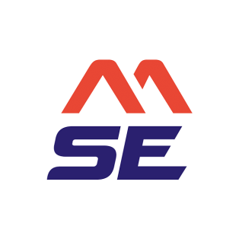
YDCCSC is affiliated to Snowsport England

